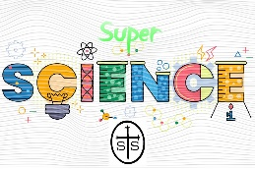
SCIENCE WEEK 2024
15th-19th April
Our science week theme is ‘Sustainable Development’.
In school, each class will be spending the week doing lots of interesting and fun activities across the curriculum linked to one of the UN Sustainable Development Goals.
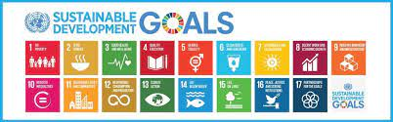

Our science ambassadors have been busy organising:
- a raffle – 50p per strip
(tickets will be on sale in the junior playground before and after school all week, winners will be drawn in assembly on Friday afternoon)
- own clothes day with a science hat - £1
(Friday 19th April)
- a competition – design a lab coat
(Information to follow after Easter. Entries to class teachers by Wednesday 24th April. All entries will be displayed in school and the winners announced in assembly on Friday 26th April)

Thank you

Science hat examples:
