**OXTON ST SAVIOUR’S CHURCH OF ENGLAND**

**(Voluntary Aided)**

**PRIMARY SCHOOL**



**Information about our Governing Body**

**Welcome to Governing Body**

The governing body is the school’s accountable body. It is responsible for the conduct of the school and for promoting high standards. The governing body aims to ensure that children are attending a successful school which provides them with a good education and supports their well-being.

As governors of the voluntary aided school with religious character we have a legal responsibility to ensure that the school is conducted according to the Christian values and the teachings of the Church of England.

However, whilst all governors share the same generic responsibilities it is the foundation governors who are appointed in order to fulfil special legal responsibilities.

**SAFEGUARDING**

The nominated governor for child protection Dr H Butterworth.

|  |  |
| --- | --- |
| **GOVERNING BODY** | |
| **CHAIR OF GOVERNORS:**  **Foundation DBE governor**  **Mrs S. Gerrie**  (Term of office 25/07/2025) | **VICE CHAIR:**  **Foundation DBE Governor:**  **Canon Dr Jon Richardson**  (Term of office 12/08/2026) |
| **Head teacher Governor: Mr A Ramsden** | **Staff Teacher Governor: Mrs Wilkinson**  (Term of office 31/10/2025) |
| **Foundation DBE Governor: Mrs Tracey Williams**  (Term of office 03/09/2026) | **Clerk to the Governors: Mrs J Mulla** |
| **Foundation PCC Governor: Mrs J Unwin**  (Term of office 20/10/2028) | **Foundation PCC Governor: Vacancy** |
| **Foundation PCC Governor: Dr Helen Butterworth**  (Term of office 20/02/2029) | **Parent Governor Mrs S Elliot**  (Term of office 20/02/2029) |
| **Parent Governor: Mr J Zacharias**  (Term of office 20/02/2029) |  |

**Body of Appointments**

|  |  |
| --- | --- |
| **Parents** | **Parent Governors** |
| **Staff** | **Staff Governors** |
| **Governing Body** | **Head teacher** |
| **PCC** | **Foundation Governors** |
| **DBE** | **Foundation Governors** |

**COMMITTEES OF THE GOVERNING BODY 2024/25**

|  |  |
| --- | --- |
| **CURRICULUM (Teaching & Learning, Achievements & Standards)**  **Chair – Mr A Ramsden** | **Mr A Ramsden, Mrs T Williams, Mrs C Wilkinson, Mrs S Elliot, Mr R Zacharias.** |
| **RESOURCES (Finance, H&S and Pay & Personnel)**  **Chair – Mr A Ramsden** | **Mr A Ramsden, Mrs S**  **Gerrie, Mrs T Williams, Canon Dr Jon**  **Richardson** |
| **ADMISSIONS**  **Chair – Mr A Ramsden** | **Mr A Ramsden, Dr H Butterworth**  **Ms J Unwin** |
| **APPRAISAL REVIEW**  **Chair – Mrs S Gerrie** | **Mrs S Gerrie, Canon Dr Jon Richardson** |

**Register of interest**

The governors have completed and signed a pecuniary interest form to notify the school of any register of interest. **There are currently no declared pecuniary interests.**

There are no relationships between governors and members of the school staff.

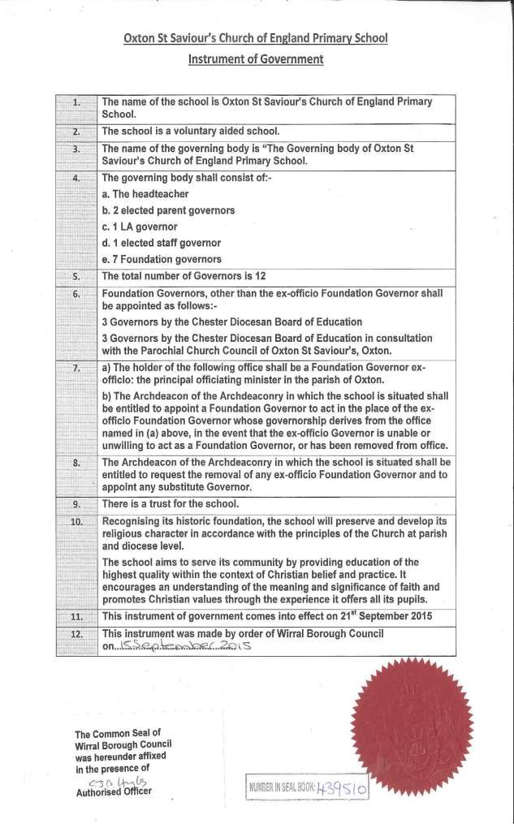

|  |  |  |  |  |  |  |  |
| --- | --- | --- | --- | --- | --- | --- | --- |
| ***Category*** | ***FIRST NAME*** | ***SURNAME*** | ***Term of Office***  ***Began*** | ***Term of Office***  ***Ends*** | ***Appointing***  ***Body*** | ***Business and/or personal interests with school***  ***(spouse/parent/ relative)*** | ***Member of any of educational establishment?*** |
| Headteacher | Andy | Ramsden | Ongoing exofficio | Ongoing ex-officio | FGB | None declared | None declared |
| Foundation  DBE | Sue | Gerrie | 21/04/2024 | 25/12/2024 | Diocese | None declared | None declared |
| Foundation  DBE | Janine | Unwin | 21/10/24 | 20/10/2028 | Diocese | None declared | None declared |
| Foundation  PCC | Nick | Porter | 17/11/2020 | 17/11/2024 | Diocese | None declared | None declared |
| Foundation  PCC | Tracey | Williams | 03/09/2022 | 03/09/2026 | Diocese | None declared | None declared |
| Foundation  DBE | Jon | Richardson | 12/08/2022 | 12/0/2026 | Diocese | None declared | None declared |
| Chair of  Governors  Parent | Alison | Williams | 10/02/2021 | 10/02/2025 | Parents | None declared | None declared |
| Staff | Cathy | Wilkinson | 31/10/2021 | 31/10/2025 | Staff | None declared | None declared |